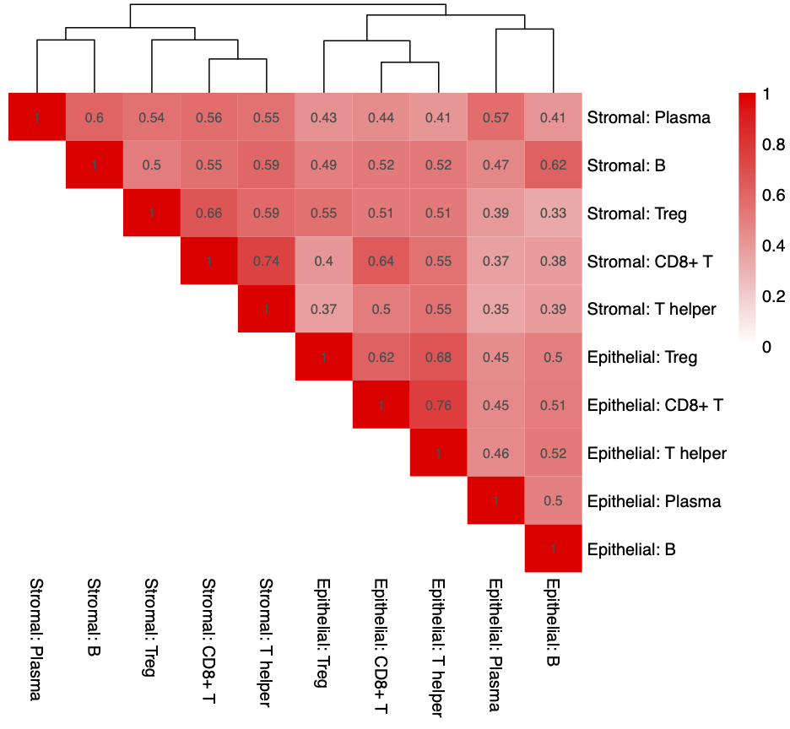

*Figure S1*: Pairwise correlations between epithelial and stromal TIL densities across the entire cohort. Colors and numbers within the heatmap correspond to the Pearson correlation coefficient (*R*). All pairwise comparisons were statistically significant (adjusted *P* < 0.001).

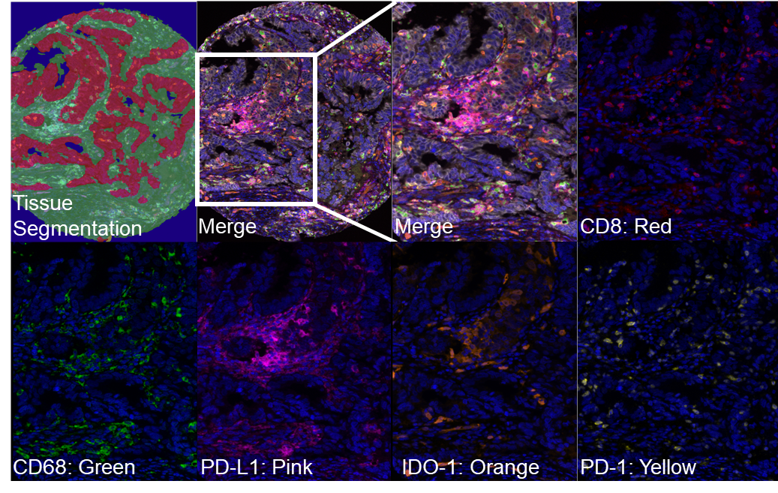

*Figure S2*: Representative multiplex immunofluorescence for the adaptive resistance panel. Representative segmentation of the tumor (red), stromal (green), and glass/necrosis (blue) are shown in the top left panel. Each image shows a single immune marker as annotated in addition to DAPI staining, or the merged image.

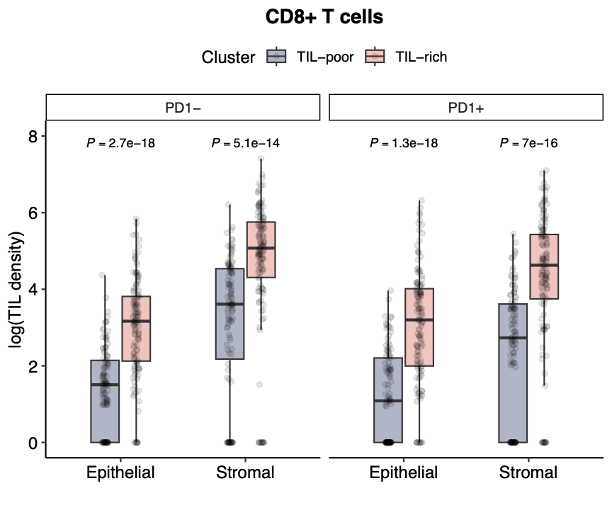

*Figure S3.* Epithelial and stromal TIL densities of PD-1 positive and PD-1 negative CD8+ T cells in TIL-rich and TIL-poor cases.

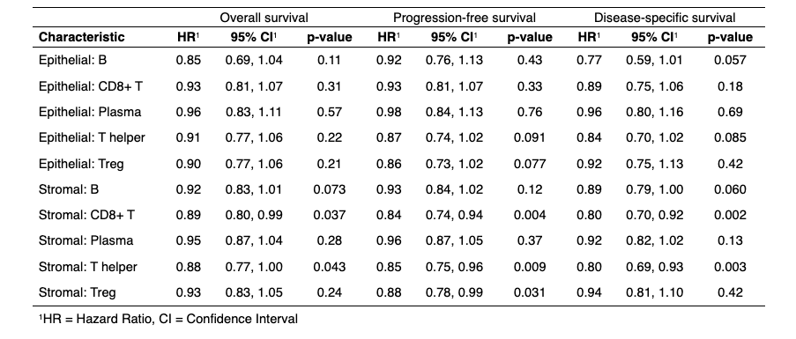

*Table S1:* Hazard ratios, 95% confidence intervals and significance values for each TIL type when analyzed individually in multivariate survival analysis including all other clinicopathologic variables (age, chemotherapy, radiotherapy, brachytherapy, and stage).

## **Supplemental Methods**

### Multiplex immunofluorescence

TMAs were cut at 4 um for immunofluorescence. Slides were first deparaffinized with xylene and graded alcohols (Fisher), then incubated for 20 minutes in 10% neutral buffered formalin (Sigma) followed by a wash in deionized water. Diva Decloaker solution (Biocare) was used for antigen retrieval, and slides were stained in an Intellipath FLX Autostainer (Biocare) in six rounds. Endogenous peroxidases were blocked with peroxidased-1 (Biocare) for 5 minutes as the first step in each round, and the slides were microwaved in AR6 (Akoya) to denature the reagents as the last step in each round. Each round included non-specific binding blocker with Background Sniper (Biocare) or Background Terminator (Biocare). Antibodies were diluted in Da Vinci Green diluent (Biocare) at the concentrations indicated below. Antibody, polymer, and flours were unique for each antigen target in panel 1 as follows: Round 1 was blocked for 12 min then anti-CD79a (clone SP18, Abcam; 1:500 dilution) was incubated for 30min, followed by Mach2 Rabbit-HRP polymer (Biocare) incubation for 10 minutes then OPAL520 (Akoya, dilution 1:500) for 10 minutes. Round 2 was blocked for 10 minutes then anti-CD20 (clone L26, Biocare, dilution 1:300) was incubated for 30 minutes, followed by incubation with Mach2 Mouse-HRP (Biocare) for 10 minutes and OPAL620 (Akoya, dilution 1:200) for 10 minutes. Round 3 was blocked for 5 minutes then anti-CD8 (clone C8/144B, Cell Marque, dilution 1:600) was incubated for 30 minutes, followed by incubation with Mach2 Mouse-HRP (Biocare) for 10 minutes and OPAL690 (Akoya, Dilution 1:100) for 10 minutes. Round 4 was blocked for 5 min then anti-CD3 (clone PS1, Biocare, dilution 1:100) was incubated for 30 minutes, followed by incubation with Mach2 Mouse-HRP polymer for 10 minutes and OPAL480 (Akoya, dilution 1:100) for 10 minutes. Round 5 was blocked for 12 minutes then anti-FoxP3 (clone 236A/E7, Fisher Scientific, dilution 1:100) was incubated for 30 minutes, followed by incubation with Mach2 Mouse-HRP polymer for 10 minutes and OPAL570 (Akoya, dilution 1:200) for 10 minutes. Round 6 was blocked for 5 minutes, then panCK (Biocare, clone AE1/AE3 + 5D3, dilution 1:100) was incubated for 30 minutes, followed by incubation with Mach2 Mouse-HRP polymer for 10 minutes and TSA_DIG (Akoya, Dilution 1:100) for 10 minutes. This was followed with incubation with OPAL780 anti-DIG (Akoya, dilution 1:25) for 60 minutes. Finally, the nuclei were counter-stained with Spectral DAPI (Akoya, dilution 2 drops per 1000 µl) for 5 minutes. The second panel followed a similar overall scheme. Each round was incubated in Peroxidazed-1 for 5 minutes to block endogenous peroxidase and Background Sniper was used for all rounds for 10 minutes except for round 4 where it was incubated for 5 minutes. Each round was incubated with Mach2 Mouse-HRP polymer for 10 minutes. In Round 1, anti-CD8 (Cell Marque, clone C8/144B, dilution 1:600) was incubated for 30 minutes, followed by incubation with polymer and OPAL620 (Akoya, Dilution 1:300) for 10 minutes. In Round 2 anti-IDO1 (Abcam clone SP260, dilution 1:7500) was incubated for 30 minutes, followed by incubation with polymer for 10 minutes and OPAL480 (Akoya, dilution 1:100) for 10 minutes. In Round 3 anti-CD68 (Abcam, clone SP251, Dilution 1:300) was incubated for 30 minutes, followed by incubation with polymer for 10 minutes and OPAL520 (Akoya, dilution 1:500) for 10 minutes. In round 4 anti-PD-L1 (Abcam, clone SP142, dilution 1:100) was incubated for 30 minutes, followed by incubation with polymer for 10 minutes and OPAL570 (Akoya, dilution 1:300). In round 5 anti-PD-1 (Cell Marque, clone NAT105, dilution 1:200) was incubated for 30 minutes, followed by incubation with polymer for 10 minutes and OPAL690 (Akoya, dilution 1:100) for 10 minutes. In round 6 anti-PanCK+ (Biocare, clone AE1/AE3+5D3, dilution 1:100) was incubated for 30 minutes, followed by incubation with polymer for 10 minutes and TSA_DIG (Akoya, Dilution 1:100) for 10 minutes. This was followed with incubation with OPAL780 anti-DIG (Akoya, dilution 1:25) for 60 minutes. Finally, the nuclei were counter-stained with Spectral DAPI (Akoya, dilution 2 drops per 1000 µl) for 5 minutes.

For each panel, a coverslip was added with Prolong Diamond cover slipping media (Fisher) and imaged using the Vectra Polaris multispectral imaging system (Akoya). They were scanned using the “motif” settings to create a whole slide multispectral QPTIFF file.